**Proposal title: PCA Design Process Improvement**

**Team members: Tiffany Morisak, Robert Wilhelm, Jason Korchuk, Cody Hutchins, April Freier**

**Sponsor: RTLogic**

**Advisor: Dr. Perera**

**Course: ECE 4890**

**Date: December 12th, 2016**

Table of Contents

Problem Overview [Tiffany Morisak] 2

Problem statement [Tiffany Morisak] 2

Requirements Analysis [Robert] **Error! Bookmark not defined.**

Requirements Specification [Robert] **Error! Bookmark not defined.**

Operational description [Jason] 4

Considerations [Jason] 4

Block diagram [Cody] **Error! Bookmark not defined.**

System Design Expectations [Cody] **Error! Bookmark not defined.**

Draft Budget [April] 7

Deliverables [April] 7

Appendix [Jason] **Error! Bookmark not defined.**

Compiled By … [Cody] **Error! Bookmark not defined.**

# Problem Overview [Tiffany Morisak]

RTLogic builds specialized RF translation circuits to allow users to translate Satellite L band signals to computer interpretable signals. The current range of translation is from 950-2500 MHz. Our task will be designing a modified version of the board that will increase the range to 6000 MHz

* Set up a testing environment to simulate a Monte Carlo set of variables to determine possible causes of signal degradation.
* Set up a testing environment that accounts for thermal dynamics.
* Create a new design which can increase the tunable range to 6000 MHz
* Build prototype (Stretch Goal)
* Test Prototype (Stretch Goal)

# Problem Statement [Tiffany Morisak]

**Set up Testing Environment:** Using circuit simulations design a set of “Monte Carlo” tests that can simulate different variations in the circuit to attempt different outputs.

**Test within Thermodynamic Framework:** Using the Thermotron, become familiar with the testing

Of the circuit within a thermodynamically effected environment.

**Create an Adjusted Design:** Upon completion of data analysis, through the efforts of this design project, selected test data will be further analyzed to uncover the cause of marginal test results.

**Build Prototype:** Build a functional version of the board that can be used to simulate the desired conditions of the board.

**Test board in accordance with original board specification:** Test board to the same environment of the original board but with new outlined specifications.

**Requirements analysis [Robert Wilhelm]**

|  |
| --- |
| Test Board |
| Test Board Thermodynamics |
| Simulate Board |
| Compare Test to Simulation |
| Design Board Solution |
| Prototype Solution |
| Test Prototype |

**Requirements specification [Robert Wilhelm]**

The goal of this RTLogic project is to understand the Saturn Board and its function in such a way to improve its frequency range and operational temperatures.

|  |  |
| --- | --- |
| Type | Value |
| Tolerances (Inductor, Capacitor, Resistor) | TBD |
| Input Frequency | 950 MHz to 6000 MHz |
| Instantaneous Bandwidth | 54 Mhz |
| 10 MHz Reference Oscillator input | +/-3 dBm input level* |
| Typical Operating Input Power | -60 dBm to -25 dBm |
| Data Storage | 65000 records |
| Measurement Speed | 1 per second |
| Automatic Monitoring Plan | 1 |
| Number of Carriers | 300 |
| Gain Stability Over 24 hours | ±0.25 dB Over 24 hours at 25⁰ C |
| Frequency Inversion | Non-Inverting |
| CPU | Freescale i.MX6Q Quad Core 1GHz clock |
| RAM | 2GB DDR3 for processor |
| Onboard Storage | SD Card 32GB |
| Operating Temperature | 0C to 50C* |
| Humidity | 5% to 95% non-condensing* |
| Power (Typical) | 500mA@5v, 900Ma@3.3v, 50Ma@-12v |
| Width | 7.72” (19.6cm) |
| Depth | 5.65” (14.35cm) |
| Height | 1.22” (3.1cm) |
| Weight | 1.65lBs (0.75kg) |
| RF Connector | SMA In (50 Ohms) |
| Product IO and Monics Interface | RJ45 |
| External 10 MHz Input | BNC |
| AC Supply | 100-200V AC, 50/60Hz |
| DC Output | 20W Maximum |
| Fuse Rating (Operational) | 1.5 A/12V DC |

# Operational Description [Jason Korchuk]

The Revised Saturn board will need to have an improved operational range in the both temperature and frequency.

# Considerations [Jason Korchuk]

The team consists of five members April Freier, Cody Hutchins, Jason Korchuk, Tiffany Morisak, and Robert Wilhelm. Cody Hutchins is in a Computer Engineering major in UCCS, with interest in Hardware programing in Verilog, and C. In the future Cody hopes to work with an automobile companies on improving hardware security of automotive electronics. Jason Korchuk is in a Computer Engineering major at UCCS, with interest in Digital Design and embedded systems. In the future Jason hopes to work for a local company that focuses on Digital Design in Verilog. Tiffany Morisak is in an Electrical Engineering major in UCCS, experienced in PCB layouts and testing, interested in PCB design and assembly. In the future Tiffany plans to work for an automotive industry designing the “bells and whistles” (optional upgrades to comfort, safety, and performance). Robert Wilhelm is in an Electrical Engineering major in UCCS, interest’s in ASIC’s and anything circuit/computer hardware. In the future Robert plans to find a local job in ASIC design and communication. April Freier is in a Computer Engineering major in UCCS, interests in high level programming and the middle ground of hardware/software. In the future April plans to get a job in software engineering.

A few missing skills that will be needed to complete this project are as follows. No team member has real experience in RF analysis. A course in Microwave Circuits has been taken but it was a rough overview of what is going to be needed. Also, the team doesn’t have experience in team management, however this will be learned as the team progresses through this project.

For this project the team does not know of any existing solutions for the design of this project. The team has a time limit until May 5 to complete this project. As for financial limits UCCS is giving $500 for the completion of this project.

**Block Diagram [Cody Hutchins]**

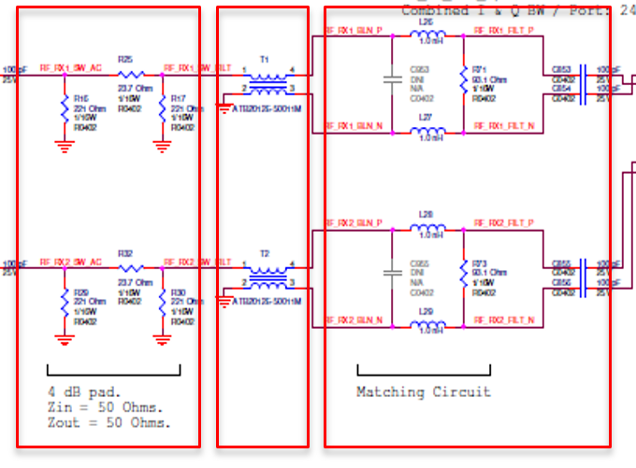

**System Design Expectations [Cody Hutchins]**

The design expectations of this project will be to quickly and effectively design a modified Saturn Board which can improve upon the current boards operational temperature and frequency ranges. It is a basic expectation that the current board follows all the original specifications of the current model of Saturn Board while expanding on the temperature and frequency ranges. The expectations can include but are not limited to, the dimensions of the current board, the power consumption of the current board and the Back-End circuitry of the current board.

# Draft Budget [April Freier]

|  |  |
| --- | --- |
| Item | Price |
| All Items Provided |  |

# Deliverables [April Freier]

Our team will construct a board design which can better account for external dependencies and increase the operational range of both operational temperature and frequencies.